**Rayat Shikshan Sanstha’s**

**Karmaveer Bhaurao Patil College of Engineering, Satara**

**Computer Science and Engineering Department**

SYNOPSIS

**Title:**

Travel Website

**Group:** Hack Elite

* 02 Omkar Avghade
* 11 Prasenjit Bhosale
* 15 Aniket Chavan

# Objectives of Project:

1. Provide a user-friendly interface for customers to browse and book their desired travel destinations.
2. Offer a seamless and secure payment gateway integration to facilitate online payments for bookings.
3. Utilize Firebase to store and manage customer information, bookings, and other relevant data.
4. Offer comprehensive information about various travel destinations, including images, descriptions, and pricing details.
5. Allow customers to search and filter destinations based on their preferences, such as location, price, amenities, and availability.
6. Provide a personalized user experience by allowing customers to create accounts, save their preferences, and view their booking history.
7. Implement booking confirmation and notification system to provide customers with real-time updates on their bookings.

# Literature Review:

1. // NOT Complete
2. Lorem ipsum dolor sit amet, consectetur adipiscing elit. Sed ultricies tempus risus, nec pretium sapien. Nullam id consectetur est. Fusce congue vehicula odio, ac tincidunt turpis viverra vel. In mollis dapibus felis, a bibendum justo auctor in. Sed blandit ullamcorper sapien, ut ullamcorper massa fermentum vitae.

# Mind map Diagram:

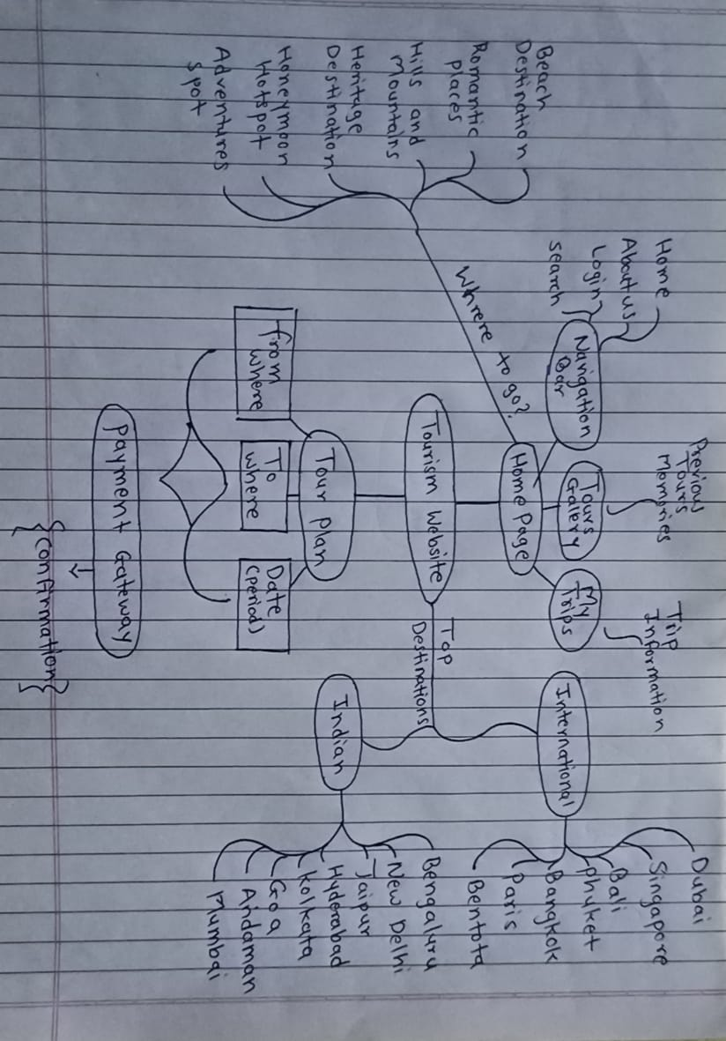

# System Architecture:

1. // This includes uml diagram too

# Technology Used:

* HTML (Hypertext Markup Language): Used for creating the structure and content of web pages.
* CSS (Cascading Style Sheets): Used for styling and formatting the web pages, including layout, fonts, colors, and other visual elements.
* JavaScript (JS): A programming language that allows for dynamic and interactive features on web pages, such as form validation, animations, and user interactions.
* Firebase: A real-time database and backend-as-a-service (BaaS) platform provided by Google that can be used for handling data management, authentication, and other server-side functionality.
* Payment Gateway: Integration of a payment gateway to enable secure and convenient online payments for bookings, such as PayPal, Stripe, or other popular payment gateways.
* Responsive Web Design: Designing the website to be responsive and adapt to different screen sizes and devices, using technologies like media queries and responsive design frameworks.
* Server-side Technologies: Such as PHP, Node.js, or Python, for handling server-side logic, processing form submissions, and interacting with databases.
* APIs (Application Programming Interfaces): Utilizing APIs provided by third-party services for functionalities like weather information, mapping, or social media integration.
* Version Control: Using version control systems like Git for managing source code and collaborating with team members.

# Advantages :

1. Time and Cost Savings: Tours and travel websites allow travelers to compare prices and options easily, saving time and money in the process. These websites often offer exclusive deals and discounts, making it easier for users to plan their trips within their budget.
2. Easy Booking and Planning: With tours and travel websites, users can book flights, hotels, and activities quickly and easily, all in one place. This eliminates the need for users to navigate multiple websites or apps, streamlining the booking process.
3. Detailed Information: Tours and travel websites provide detailed information on destinations, hotels, and activities, making it easier for users to plan their trips. This includes reviews and ratings from other travelers, providing valuable insights and recommendations.
4. Customer Support: Tours and travel websites often provide 24/7 customer support, ensuring that users can get help and assistance whenever they need it. This provides peace of mind for users, knowing that they can get help if anything goes wrong.
5. Personalized Recommendations: Tours and travel websites can provide personalized recommendations based on the user's travel history and preferences. This makes it easier for users to discover new destinations and activities that they may not have considered before.

# Limitations:

1. Dependence on Technology: Tours and travel websites rely heavily on technology, which can be a disadvantage if the technology fails or crashes. This can cause inconvenience and disruption to travelers who rely on the website for booking and planning their trips.
2. Lack of Personal Interaction: Online booking and planning may not provide the same level of personal interaction and support as traditional travel agencies. This can be a disadvantage for travelers who prefer personalized service or face-to-face interaction.
3. Limited Customization: While tours and travel websites offer a wide range of options for booking flights, hotels, and activities, there may be limited customization options available. This can be a disadvantage for travelers who have specific requirements or preferences.
4. Language and Cultural Barriers: Tours and travel websites may not always cater to the language and cultural needs of all travelers, which can be a disadvantage for those who do not speak the dominant language or are not familiar with the culture of the destination.
5. Trust Issues: With the rise of online fraud and scams, travelers may be hesitant to trust tours and travel websites, especially those that are not well-established or reputable

# Future Scope:

* Artificial Intelligence (AI) and Machine Learning (ML): AI and ML can help tours and travels websites provide personalized recommendations and suggestions based on the traveler's preferences and history. This can enhance the user experience and increase customer satisfaction.
* Augmented Reality (AR) and Virtual Reality (VR): AR and VR can provide a more immersive and engaging travel experience, allowing travelers to explore destinations and activities before they book.
* Blockchain Technology: Blockchain technology can provide a more secure and transparent booking and payment process, reducing the risk of fraud and ensuring privacy for travelers.
* Internet of Things (IoT): IoT can provide real-time data and insights on travel, allowing tours and travels websites to provide more accurate and relevant information to travelers.

**Conclusion :**

In conclusion, the travel website being developed aims to provide a user-friendly platform for customers to book their desired travel destinations. The use of technologies such as HTML, CSS, JS, Firebase, and payment gateways will enable seamless functionality for browsing, booking, and managing travel bookings. Responsive web design, server-side technologies, APIs, and version control will further enhance the website's performance and user experience. The website is expected to provide a convenient and secure platform for customers to plan and book their travel, making it a valuable tool for travel enthusiasts.

**References:**

Official documentation provider : [www.w3schools.com](http://www.w3schools.com)

Online tutorials and coding blogs : JavaScript Mastery, Thapa technical & GitHub